**W1-S2** PRACTICE

*DART BASICS*

## *Before this practice*



* You need to have completed: **SELF-LEARNING 1** - Dart Syntax & Concepts

## *Learning objectives*

* Apply type **inference** for variable declarations.
* Handle **nullable** and **non-nullable** variables.
* Differentiate between **final** and **const**.
* Manipulate **strings, lists, and maps.**
* Use **loops** and **conditions** to control flow.
* Define and call functions with positional and **named arguments**, understand **arrow syntax**

# EX 1 – Manipulate Types

Output :

# EX 2 – Non-nullable and Nullable variables

# For Non-nullable

# 

# Output :

# For Nullable variable

# Output :



# EX 3 – Manipulate final and const

|  |  |  |
| --- | --- | --- |
|  | **VAR, FINAL, CONST?** | **WHY** |
| iLike | CONST | *Because this variable never changes* |
| toppings | FINAL | *The list itself is unchangeable* |
| message | CONST | *Message can change and edit* |
| rbgColors | FINAL | *For flexibility* |
| weekDays | CONST | *Since the days of the week are fixed and won't change.* |
| score | VAR | *score can be changed throughout the program* |

# EX 4 – Manipulate strings, lists, and maps.

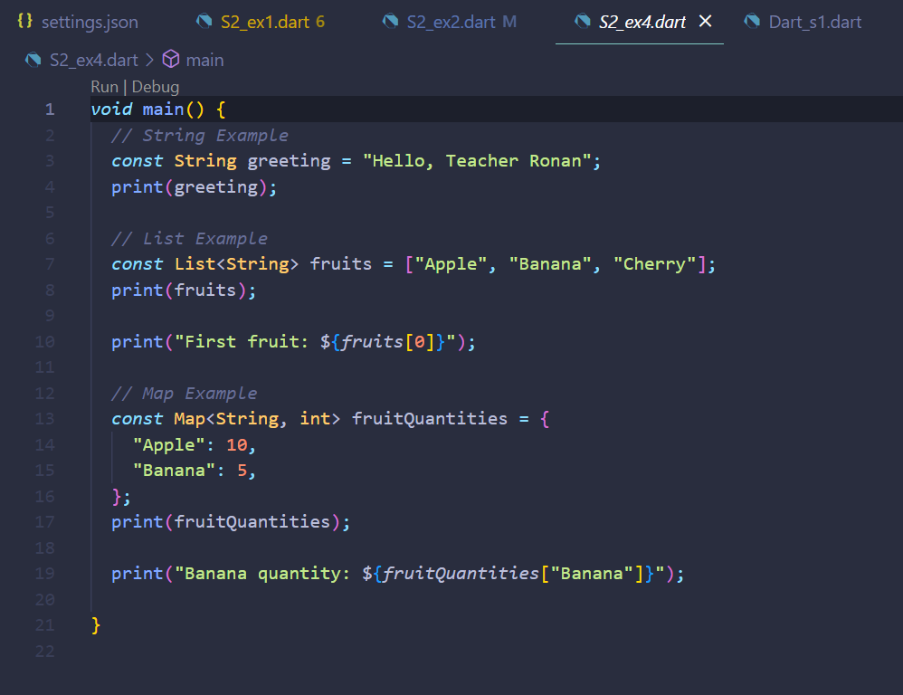

# Output :

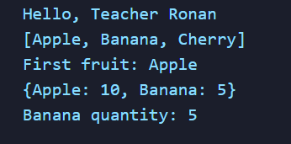

# EX 5 – Use **loops** and **conditions** to control flow.

# A screenshot of a computer program Description automatically generatedOutput :

# 

# EX 6 - Define and call functions with positional and **named arguments**, understand **arrow syntax**

# Output :

# 